FINA4150

Project 2

Group 4

*Chan Chak Wang 1155142789*

*HON Sing Yu 1155141814*

*SUN Yizhou 1155157158*

*ZHANG Haoxiang 1155141702*

CONTENT

Introduction 3

1. Initial Settings 4

2. Volatility Surface 5

2.1 Data Collection 5

2.2 Data Cleaning 5

3. Interest Rate, Dividend Yield, & Forward Price 7

4. Obtain Black-Scholes Model Implied Volatility 9

5. Local Volatility Transformation 17

6. Simulation 21

6.1 Monte Carlo Simulation of Multiple Underlyings 21

6.2 Payoff of Auto-callable Note 24

6.2.1 Knock-Out Event 24

6.2.2 Knock-In Event 25

6.3.3 No Event 25

6.3.4 Coupon Payment 25

6.3 Finding Target Coupon Strike 26

7. Appendix 27

# Introduction

This is a report aiming to find a ***coupon strike*** such that the price of the Note is close to 98% of issue price.

An Autocallable has a trade date of 1 Sep 2023 and a maturity date of 31 Oct 2025.

A Note is issued at 100% of Note Denomination per note, and the Note Denomination is USD 10,000.

There are three underlying indexes: Nikkei 225, S&P 500 and HSI.

Given interest rates under different conditions and coupon strike rate, the variable interest depends on different event.

And in the following part we will try to figure out the unknown coupon strike rate, which is:

This report’s content is only for results display.

See appendix for our detailed coding.

# Initial Settings

Trade Date: 2023-09-01

Maturity: 2025-08-31

Coupon strike: **CS**%

Maximum rate of interest: 2% per annum

Minimum rate of interest: 0.01% per annum

Observation dates: the 1st one at 6-month after Trade date

Notion Definition:

$$F_{\left(t,T\right)}≔S_{t}×e^{\left(r-q\right)×\left(T-t\right)},$$

$$\text{which is forward price at time }t\text{ with maturity }T$$

$$r_{\left(t,T\right)}≔ {\text{Time}}_{t}→{\text{Time}}_{T}$$

which is risk-free rate p.a. with continuous compounding.

$$q_{\left(t,T\right)}≔ {\text{Time}}_{t}→{\text{Time}}_{T}$$

which is dividend yield p.a. with continuous compounding.

$$C≔\text{ the mid price of the call option.}$$

$$P≔\text{ the mid price of the put option.}$$

# Volatility Surface

## 2.1 Data Collection

For our options analysis project, we'll be looking at three key types of options: those based on the S&P 500 Index (SPX), the Hang Seng Index (HSI), and the Nikkei Index. We've marked September 1, 2023, as our starting point. Here's what we'll gather:

**Option Prices:** We'll check out the prices for options on the SPX, HSI, and Nikkei as of September 1, 2023.

**Index Prices:** The actual values of the SPX, HSI, and Nikkei indexes will be noted, these will be used as S0.

**Index Correlation:** We'll measure how these indexes move in relation to each other for future simulations.

**Interest Rates & Dividend Yields:** This is important as it influences option pricing.

By collecting this data, we're setting the stage for a comprehensive analysis of option pricing trends and patterns.

## 2.2 Data Cleaning

In our analysis of option data, we have implemented a series of data refinement steps to ensure accuracy and relevance in our findings. The key modifications and criteria applied to the dataset are outlined as follows:

**1. Simplifying Data:** We removed unneeded rows and columns to keep our data set neat and manageable.

**2. Analyzing Option Tickers:** We carefully broke down the option tickers to understand the specifics of each option.

**3. Standardizing Expiration Dates:** We changed the format of expiration dates to make them easier to compare.

**4. Choosing SPX Options:** Our analysis is based solely on SPX options. We didn't use SPXW options to keep our study focused.

**5. Selecting by Volatility:** We only looked at options with more than 10% implied volatility and an upcoming expiration date. This helped us focus on the most active options in the market.

**6. Determining Option Prices:** To price options, we used the average of the bid and ask prices. This gives us a fair price point for each option.

**7. Naming Variables:** We used clear and consistent names for our variables, like `option_data_{index}`, `{index}_data`, and `option_price_{index}`. This makes our work easy to follow and update.

By following these steps, we made sure our analysis was clear, focused, and relevant to current market conditions.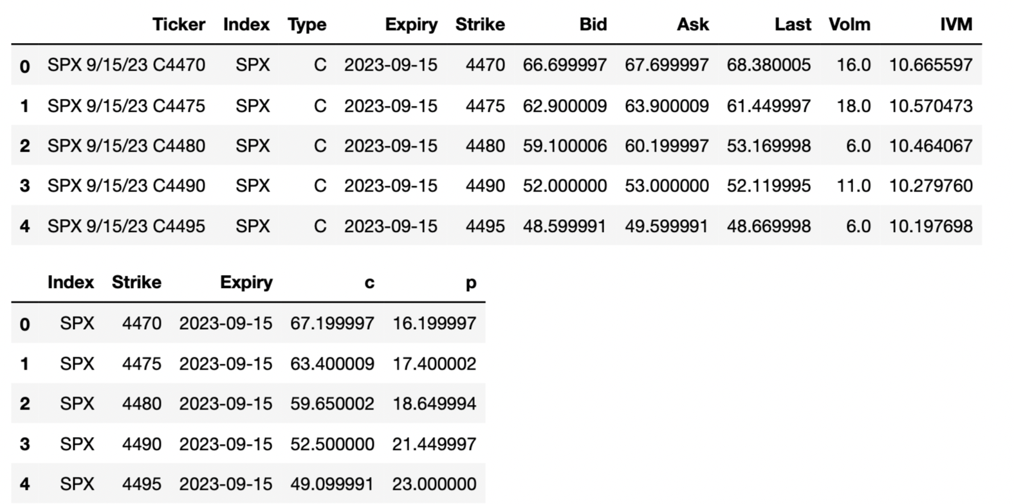

# Interest Rate, Dividend Yield, & Forward Price

In this part, we have two solutions.

Solution 1: Forward Moneyness

**In this solution, we use put-call parity to get implied interest rate and implied forward price.**

$$s = e$$

$$C-P = S_{0e}^{-q_{0,T}T}-Ke^{-r_{0,T}T} \\ = e^{-r_{\left(0,T\right)}T}\left(S_{0}e^{\left(r_{0,T}-q_{0,T} \right)T}-K\right) \\ =e^{-r_{0,T}T}\left(S_{0}e^{\left(r_{0,T}-q_{0,T}\right)T}-K\right) \\ =-e^{-r_{0,T}}\left(F_{0,T}-K\right) \\ =-e^{-r_{0,T}}K+F_{0,T}e^{-r_{0,T}}$$

By using linear regression, we can find out the target r.

$$y≔ C-P, x≔ K, y = ax + b$$

$$∴ a=-e^{-r_{\left(0,T\right)}}, b=F_{\left(0,T\right)}e^{-r_{\left(0,T\right)}}$$

$$⇒ r_{\left(0,T\right)}=-\ln\left(\frac{1}{a}\right), F_{\left(0,T\right)}=-\frac{b}{a}$$

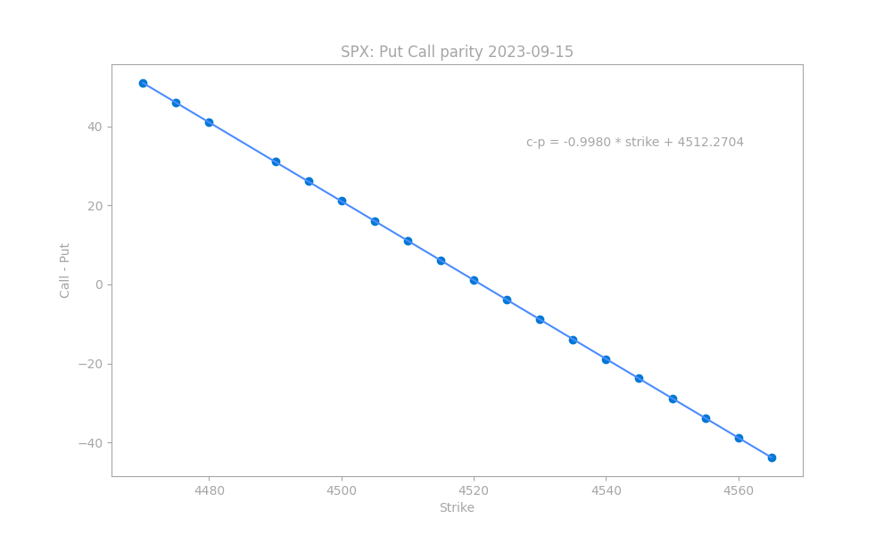

Solution2: Spot Moneyness

Here, we use interest rate data and dividend yield data from Bloomberg

$$\ln{\frac{K}{S_{t}}} ≔ Spot moneyness$$

$$S_{t}≔stock price at time t$$

The advantage of using spot moneyness is the ease of getting spot price at time t, for example, we are at 2024-01-01, then $S_{t}=S_{2024-01-01}$, which can be directly calculated by Simulation.

# Obtain Black-Scholes Model Implied Volatility

In this part, we will use Black-Scholes model to find the implied volatility first.

And to use the forward moneyness we figured out before, here we use Black-Scholes model using forward price:

$$C\left(t\right)=e^{-r_{t,T}\left(T-t\right)}\left(F_{t,T}Φ\left(d_{1}\right)-KΦ\left(d_{2}\right)\right) \\ P\left(t\right)=e^{-r_{t,T}\left(T-t\right)}\left(KΦ\left(-d_{2}\right)-F_{t,T}Φ\left(-d_{1}\right)\right) \\ Where d_{1}=\frac{\ln{\frac{F_{t,T}}{K}}+\frac{1}{2}σ^{2}\left(T-t\right)}{σ\sqrt{T-t}}, \\ d_{2}=d1-σ\sqrt{T-t} , \\ and F_{t,T}≔S_{0}e^{{(r}_{t,T}-q_{t,T})(T-t)}$$

$$ϕ is the pdf of standard normal distribution$$

And we use methods in HW1 (bisection method) to get the implied volatility:

$$σ_{implied}\left(F_{0,T},K,T,r,c\right)=σ_{implied}\left(F_{0,T},K,T,r,p\right)$$

Then, we get the implied volatility surface

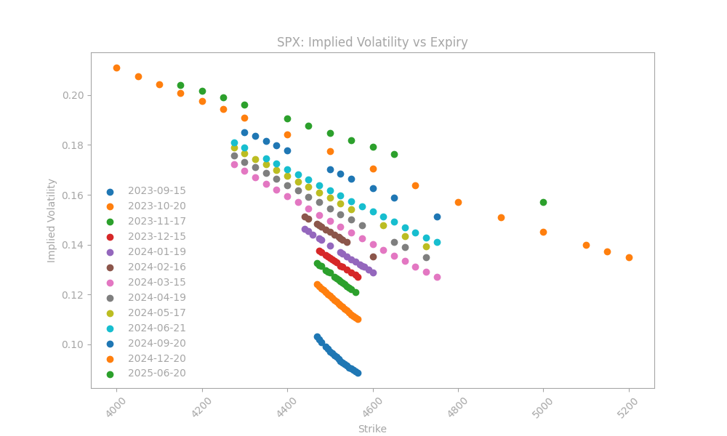

In our analysis, the calibration of the implied volatility curve is a critical step for each option's maturity. This process involves determining the Forward Moneyness, which varies for each maturity due to the differing forward prices. Forward Moneyness is calculated using the natural logarithm of the strike price divided by the forward price at time t for maturity T.

To model the implied volatility curve, we use two distinct functional forms, both of which are fitted against the spot moneyness:

1. The first approach employs a function reminiscent of the hyperbolic tangent (tanh), representing the volatility smile in a manner that mirrors the tanh function's shape.

2. The second option uses a function similar to the sigmoid, capturing the characteristics of the volatility skew.

The formula for the volatility smile in the first approach is given by the square of

$$σ{\left(x\right)}^{2}$$

which is the sum of the square of the at-the-money forward volatility

$$σ_{atmF}$$

and a transformation of the tanh function, adjusted by parameters $δ, κ, and γ$.

Here, x represents the natural logarithm of the strike price over the forward price at time 0 for maturity T.

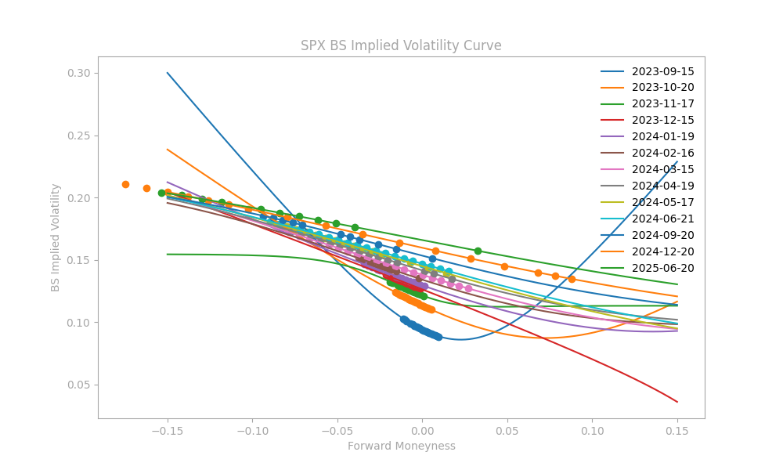

Next, we connect all implied volatility curve to surface using cubic spine:



We do the same thing for NKY and HSI: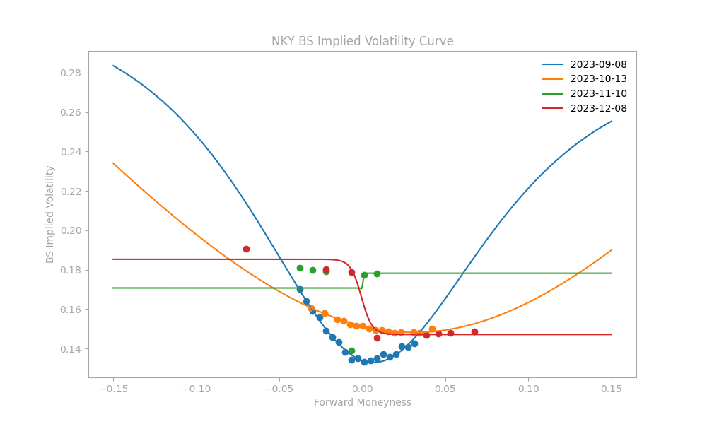



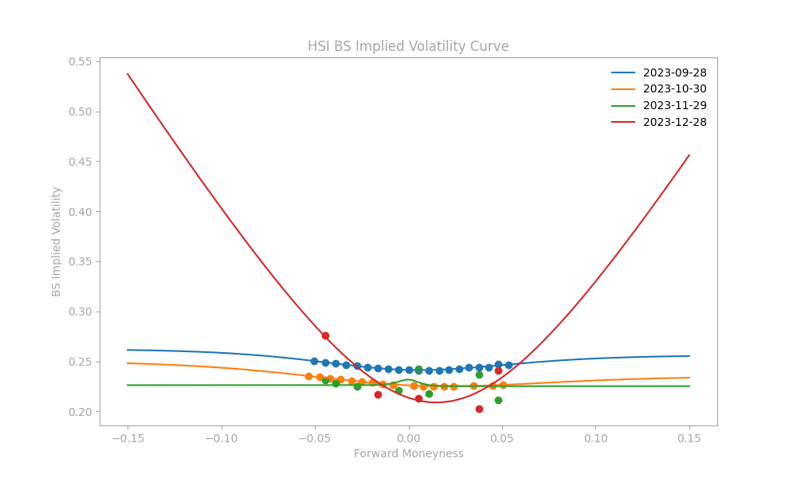

# Local Volatility Transformation

In this part, we try to Convert BS Implied Volatility Surface to Local Volatility Surface.

Dupire's formula is used to calculate the local volatility for each option:

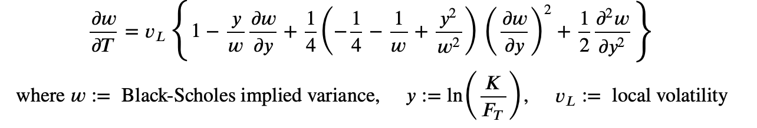

$$\frac{∂w}{∂T}=v_{L}\left\{ 1-\frac{y}{w}\frac{∂w}{∂y}+\frac{1}{4}\left(-\frac{1}{4}-\frac{1}{w}+\frac{y^{2}}{w^{2}}\right){\left(\frac{∂w}{∂y}\right)}^{2}+\frac{1}{2}\frac{∂^{2}w}{∂y^{2}}\right\}$$

$$where w≔Black-Scholes implied variance, y≔\ln\left(\frac{K}{F_{T}}\right), v_{L}:=local volatility$$

SPX

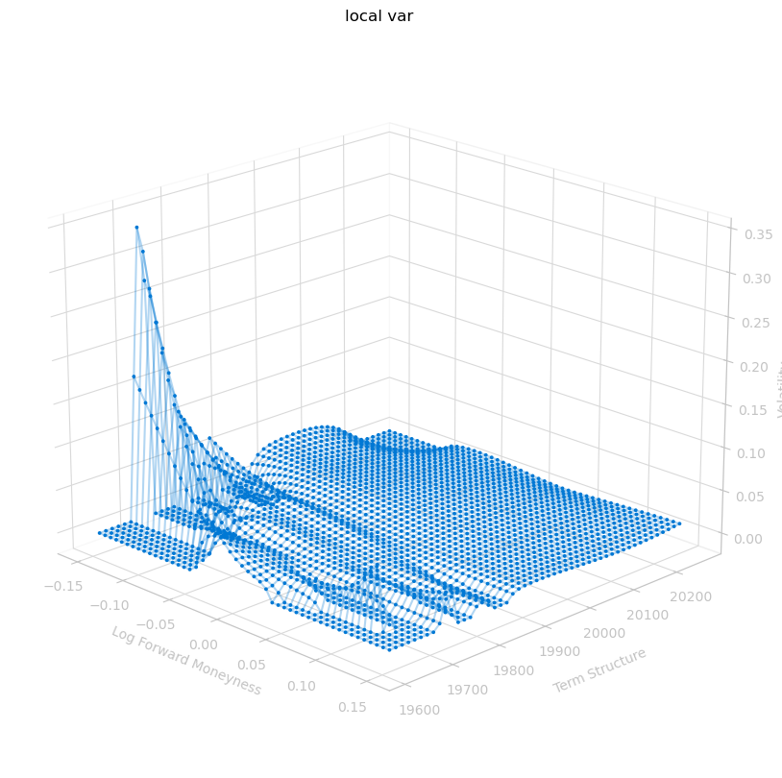

NKY

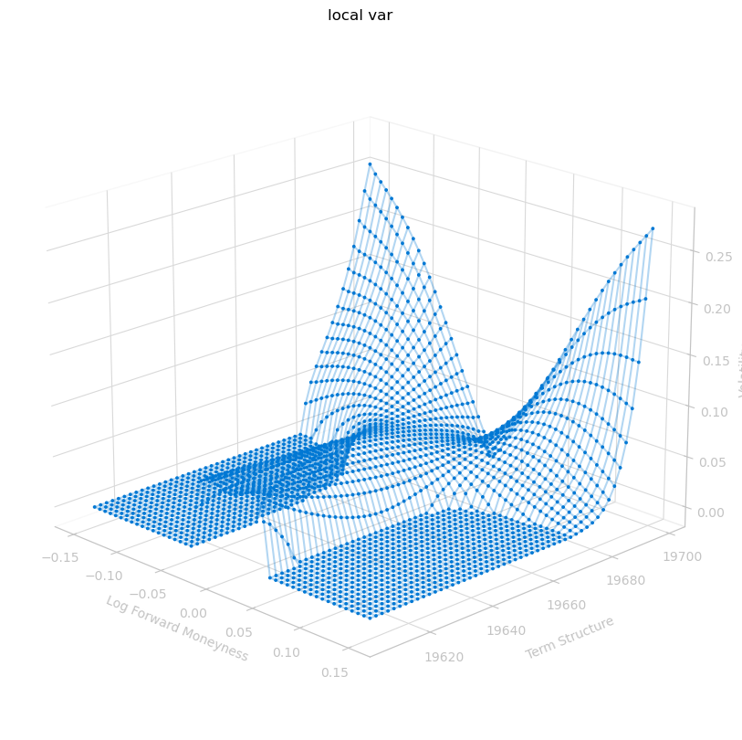

HSI

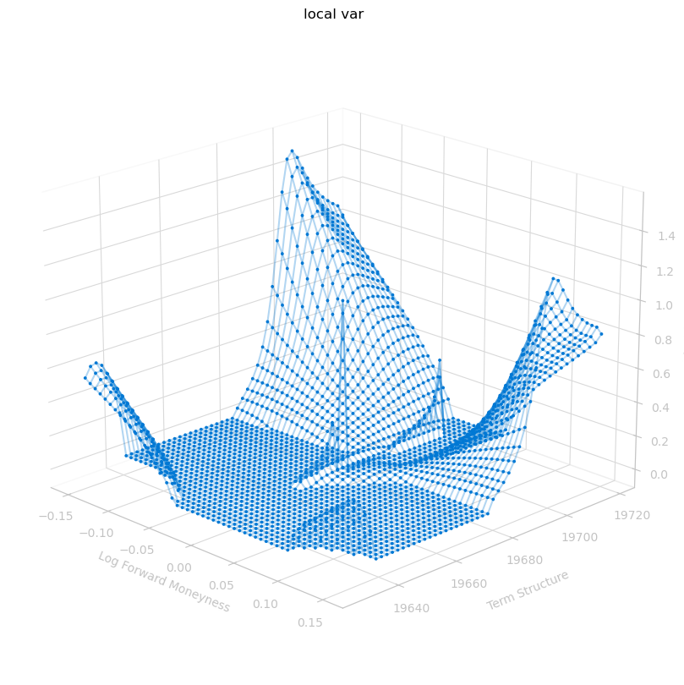

# 5* Thoughts on the local volatility transformation

We have tried to transform the BS implied vol to local vol. But we are not sure whether it is correct, since the function only use maturity time instead of current time point.

You may refer to the local_vol_trial file for reference.

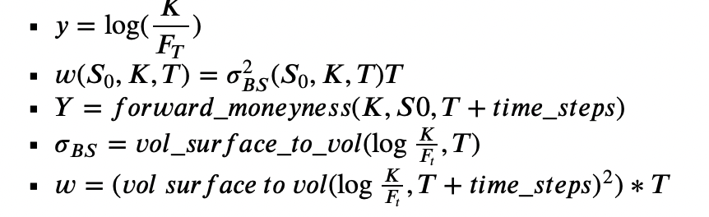

$$y=\ln\left(\frac{K}{F_{T}}\right)$$

$$w\left(S_{0},K,T\right)=σ_{BS}^{2}\left(S_{0},K,T\right)T$$

$$Y=forward_{moneyness\left(K,S_{0},T+time_steps\right)}$$

$$σ_{BS}=volatility_{surface_{to_{vol\left(\ln{\frac{K}{F_{t}}},T\right)}}}$$

$$W=(vol_surface_to_vol{\left(ln\frac{K}{F_{t}},T+times_steps\right)}^{2}×T$$

# Simulation

The simulation can be broken down into three steps:

1. Simulate the three underlying indices NKY, SPX and HSI using Monte Carlo Simulation.
2. Calculate the expected value of the autocallable based on the simulated laggard prices.
3. Find the target coupon strike.

Here, the steps will be explained as briefly as possible.

## 6.1 Monte Carlo Simulation of Multiple Underlyings

First, we simulate the indices by setting up a Monte Carlo Simulation. Their price dynamics follow the Geometric Brownian Motion (GBM).

**Geometric Brownian Motion**

$$dS_{1,t}=\left(r-q_{1}\right)S_{1,t}dt+σS_{1,t}dZ_{1,t}$$

$$dS_{2,t}=\left(r-q_{2}\right)S_{2,t}dt+σS_{2,t}dZ_{2,t}$$

$$dS_{3,t}=\left(r-q_{3}\right)S_{3,t}dt+σS_{3,t}dZ_{3,t}$$

**Stock Price Dynamics**

$$S_{t+Δt}=S_{t}e^{vΔt+σ√Δtϵ_{i}}$$

$$where v=\left(r-q\right)-\frac{1}{2}σ^{2},for i=1, 2, 3$$

For the implementation, we need to use correlated Wiener processes ($Z_{t}$) instead of the normal Wiener processes ($W_{t}$). They are generated by using the correlation matrix of the underlying indices and the Cholesky decomposition.

**Correlation Matrix**

$$ρ_{Z}=\left[\begin{matrix}1 & ρ_{12} & ρ_{13} \\ ρ_{12} & 1 & ρ_{23} \\ ρ_{13} & ρ_{23} & 1\end{matrix}\right]$$

**Cholesky Decomposition**

$$Z_{1}=W_{1}$$

$$Z_{2}=ρ_{12}W_{1}+\sqrt{1-ρ_{12}^{2}}W_{2}$$

$$Z_{3}= ρ_{13}W_{1}+ρ_{23}-\frac{ρ_{12}ρ_{13}}{\sqrt{1-ρ_{12}^{2}}}W_{2}+\sqrt{1-ρ_{12}^{2}-\frac{{\left(ρ_{23}-ρ_{12}ρ_{13}\right)}^{2}}{1-ρ_{12}^{2}}}W_{3}$$

$$\left[\begin{matrix}Z_{1} \\ Z_{2} \\ Z_{3}\end{matrix}\right]=\left[\begin{matrix}1 & 0 & 0 \\ ρ_{12} & \sqrt{1-ρ_{12}^{2}} & 0 \\ ρ_{13} & \frac{ρ_{23}-ρ_{12}ρ_{13}}{\sqrt{1-ρ_{12}^{2}}} & \sqrt{1-ρ_{12}^{2}-\frac{{\left(ρ_{23}-ρ_{12}ρ_{13}\right)}^{2}}{1-ρ_{12}^{2}}}\end{matrix} \right]\left[\begin{matrix}W_{1} \\ W_{2} \\ W_{3}\end{matrix}\right]$$

where the 3-by-3 matrix is the Cholesky factor of $ρ_{Z}$.

To put this step simply, the goal is to generate some $Z_{t}^{'}$'s such that they are the linear combinations of the $W_{t}$'s. We can make some *𝑍𝑡*'s that are sort of correlated to one another instead of deploying three independent and completely uncorrelated $W_{t}$'s.

After preparing the necessary parameters, we can launch the Monte Carlo Simulation and simulate the three indices:

(Here we only show four simulations)

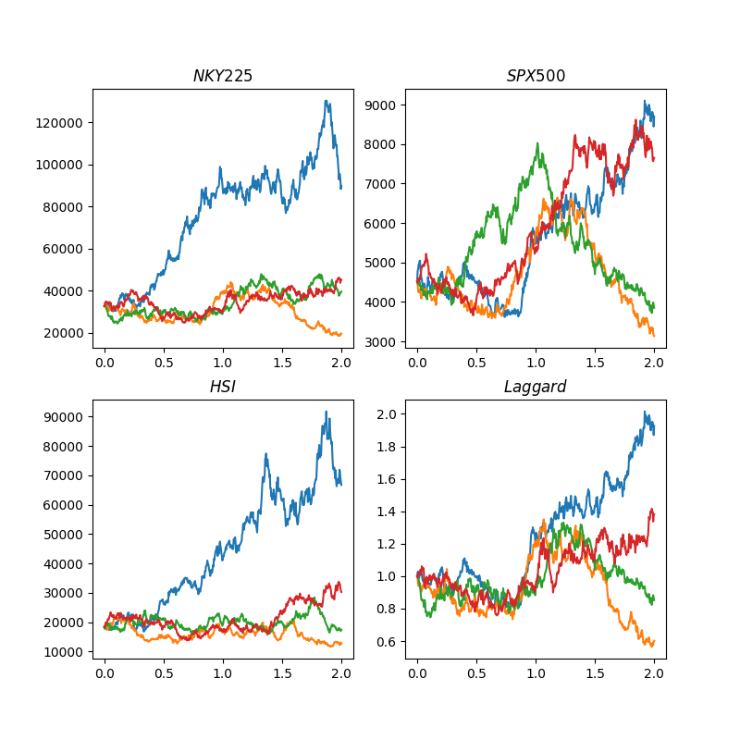

where the laggard underlying is computed using this formula:

$min(\frac{S_{t,NKY}}{S_{0,NKY}},\frac{S_{t,SPX}}{S_{0,SPX}},\frac{S_{t,HSI}}{S_{0,HSI}}$**)**

On the bottom-left chart, you can observe that the laggard underlying paths always follow those paths of the worst-performing index among the three indices. This is in line with our laggard formula.

Obtaining the simulated laggard underlying paths. We can proceed to the next step to calculate the note expected value.

## 6.2 Payoff of Auto-callable Note

Three are three possible payoffs for the auto-callable, depending on the occurrence of the following events:

* Knock-out event
* Knock-in event
* No event

### 6.2.1 Knock-Out Event

In any observation dates (every 6 months), if the laggard underlying exceeds the knock-out strike (110%), the note will expire immediately. The buyer will receive 100% of the note denomination plus the coupons paid up to that observation date inclusive. Therefore, the payoff formula is:

$$N_{t=0 }=Coupon Payments+Note Denomination$$

$$N_{t=0}=\sum_{i=0}^{k}{C_{i}e^{-\left(r-q\right)\frac{126}{225}i}}+N_{D}e^{-\left(r-q\right)\frac{126}{252}k}$$

**Where**

* $N_{T=0}$ is the present value of the note,
* $i$**-th $is the observation date,$**
* $C_{i}$ is the coupon payment,

$and N_{D} is the note denomination$

For example, if the knock-out event is triggered on the $3^{rd}$ observation date, the buyer will receive coupons $C_{1},C_{2},C_{3}$, and the note denomination $N_{D}$. Be reminded that the coupons and note principal are paid out at different points of time. Hence, they need to be discounted accordingly to find the present value of the note.

Notice that we have not yet discussed the calculation of the coupon payments. This will be addressed in the later section.

### 6.2.2 Knock-In Event

In any point of time, if the laggard underlying is below the knock-in strike (50%), at the maturity the buyer will receive the sum of all the coupons and a final redemption amount, which is calculated as the following:

$$N_{t=T}=Counpon Payments+Final Redemption Amount$$

$$N_{t=T}= \sum_{i=1}^{4}{C_{i}e^{\left(r-q\right)\left(T-\frac{126}{252}i\right)}}+N_{D}×\min\left(100\%,\frac{FinalClosingPriceOfLaggard}{SpotPriceOfLaggard} \right)$$

where ${ N}_{t=T}$ is the note value at the maturity, and $N_{D}$ is the note denomination.

### 6.3.3 No Event

If the laggard underlying does not trigger both the knock-out event on the observation dates and the knock-in event anytime during the life of the autocallable, the buyer receives a no-event payoff. Following the knock-in event, the calculation of this payoff is simple:

$$N_{t=T}=Counpon Payments+Note Denomination$$

$$N_{t=T}= \sum_{i=1}^{4}{C_{i}e^{\left(r-q\right)\left(T-\frac{126}{252}i\right)}}+N_{D}$$

where ${ N}_{t=T}$ is the note value at the maturity, and $N_{D}$ is the note denomination.

### 6.3.4 Coupon Payment

One important component in the note payoff computation is the calculation of the coupon payments. If the laggard underlying exceeds a certain threshold on the observation dates, the buyer will receive a coupon at the maximum coupon rate (10%), otherwise he/she will receive a coupon at the minimum coupon rate (5%). Hence, the coupon payment is as follows:

$$C_{i}=\left\{\begin{aligned}N_{D}×MaxCouponRate, Laggard≥CS \\ N_{D}×MinCouponRate, Laggard<CS\end{aligned}\right.$$

Now we have mapped out all the possible payoffs for the auto-callable. With one more component, we can compute the note expected value based on our laggard underlying paths simulated in the Monte Carlo Simulation.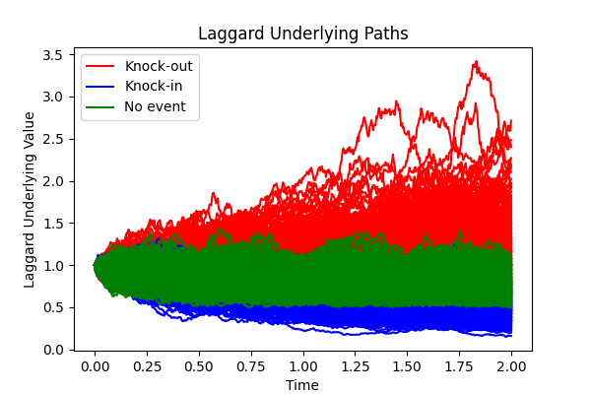

The missing component is the coupon strike, which we do not know from the outset. We need to input a random coupon strike to see how the expected note value evolves. Therefore, the final section will discuss how we can map out the coupon strike versus the expected note value, and hence find the specific coupon strike that we need.

## 6.3 Finding Target Coupon Strike

The final section is easy and straight-forward. Now we have obtained the function of which the input is the coupon strike and the output is the expected note value. Since the function cannot be solved analytically, we will use the Bisection method to find out the solution.

You can observe that when the coupon strike goes up, the note value goes down. This aligns with the logical intuition that the higher the coupon strike, the less likely coupon payments are paid out at the maximum coupon rate, the lower the note value.

In our example, the target coupon strike is **105.47%**. This is the final result that we need.

# Appendix